ITIS 6177 Final Project – Interface with Azure Cognitive Services Bing News Search

The REST API created for the project is made with Node and Express and carries out a simple POST request to retrieve JSON Response data from the Azure Cognitive Services Bing News Search.

- URL for POST Request: http://45.55.54.185/news

-Github Repo: <https://github.com/jhutch50/itis6177finalproject>

Using the API

1. Go to Postman and type in the url for <http://45.55.54.185/>
2. The resource for the project is simply “news” (http://45.55.54.185/news), so for the POST request, a user will send a search term in the body under the variable name “news_search”.
3. Each time a user types in a term for the “news_search” variable, the payload will be sent to the server and it will retrieve a json response of news related to that term.
4. Full example can be found using the Postman API Doc created for the project found here: <https://documenter.getpostman.com/view/7246999/SWDzdgB5?version=latest>

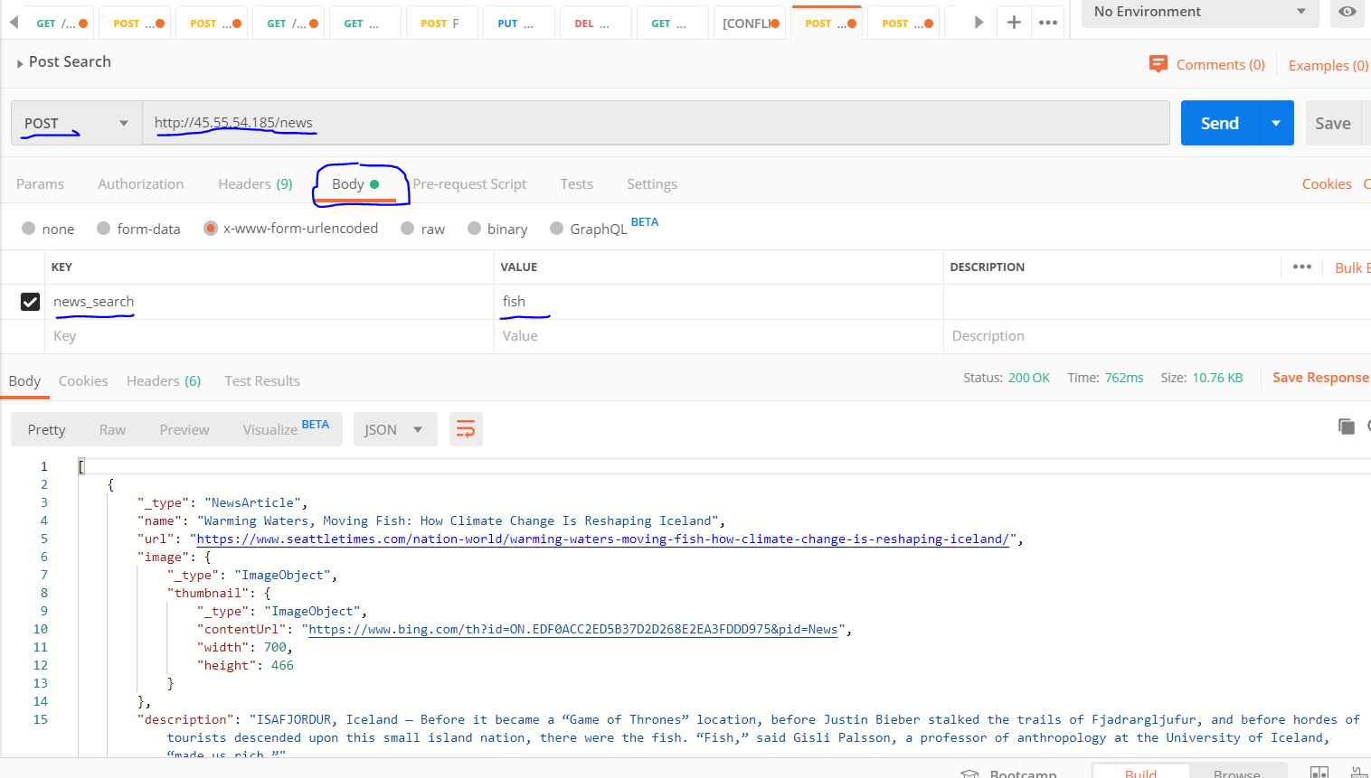

JWT - help from documentation: https://www.npmjs.com/package/jsonwebtoken

1. Though the code is commented out, a user would have originally first had to create an account, which was represented by a user object. This user would then have a code generated for them based on a GET request under the resource “login”. For testing purposes, the user was created as test within the code itself.
2. When trying to use the API, the user would have had to have had their token used under the header with the key of “Authorization” and the value of “Bearer [TOKEN]”. A function would split the word “Bearer” from the token and assign it to the request object. If the token matched the one generated for the user, then it would have allowed the user to continue using the API as listed above.

